**A PROJECT ON**

**“INDIAN AGRICULTURAL CROP PRODUCTION”**

**Submitted by,**

**J. Jaison Immanuel**

**R. Jenisha**

**S. Sowmiya**

**Bishop Appasamy College of Arts & Science, Coimbatore**

**INDIAN AGRICULTURE CROP PRODUCTION**

**1. INTRODUCTION:**

In this project we have discussed about India’s agricultural crop production.

**1.1 OVERVIEW:**

Here we have represented the India’s crop production details in visualization form using Tableau.

**1.2 PURPOSE:**

* To compare and analyze the crop production in various seasons
* To understand state-wise production of various crops.

**2. PROBLEM DEFINITION AND DESIGN THINKING**

In order to analyze and understand the project, empathy map and brainstorming map were used.

**2.1 EMPATHY MAP:**

The following is the empathy map screenshot of our project

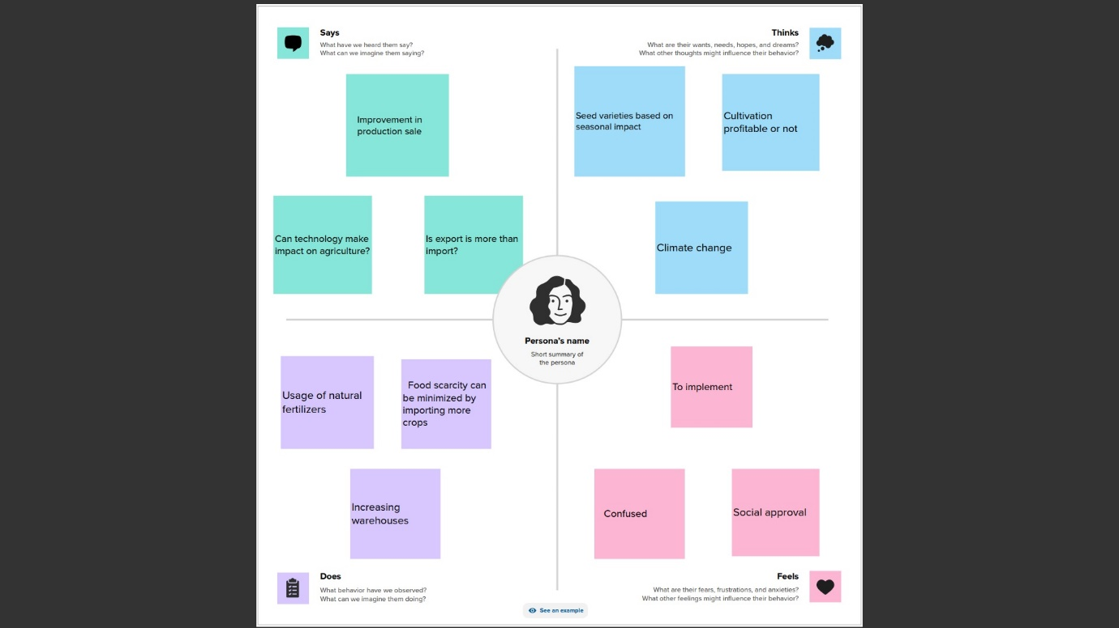

**2.2 IDEATION & BRAINSTORMING MAP:**

The following is the brainstorming map screenshot of our project

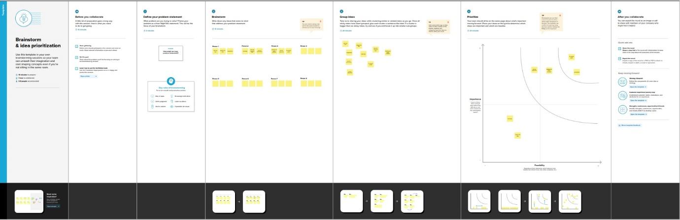

**3. RESULT:**

Here we have analyzed the Indian agriculture crop production data and have compared and represented the data visually using tableau.

The result (output) of the visualizations are represented here as screenshots.

**Sheet 1- Statewise Agricultural Land**

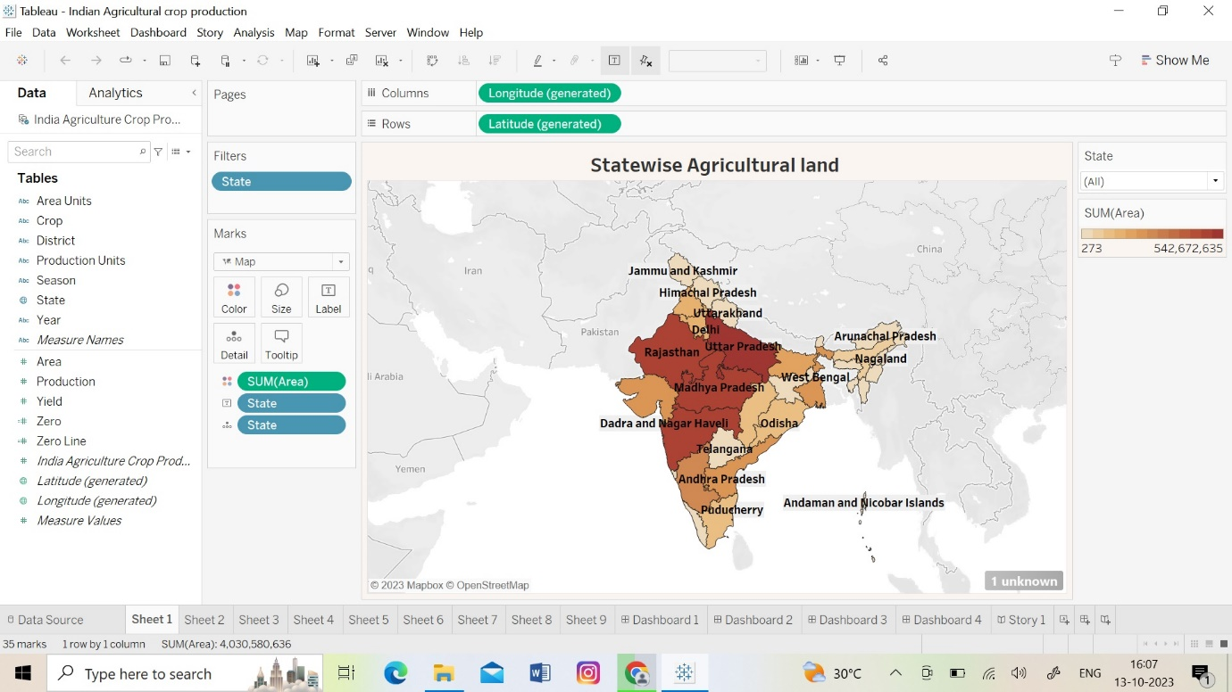

**Sheet 2- Area VS Production**

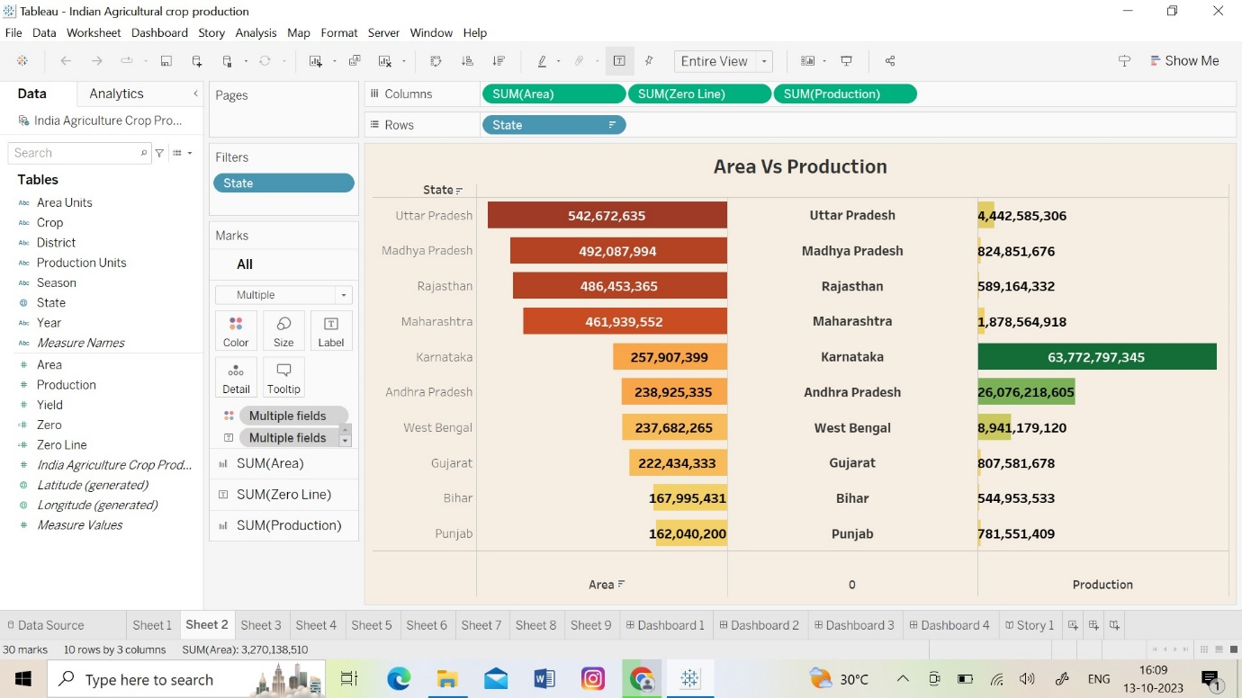

**Sheet 3- Season Based Cultivation Area**

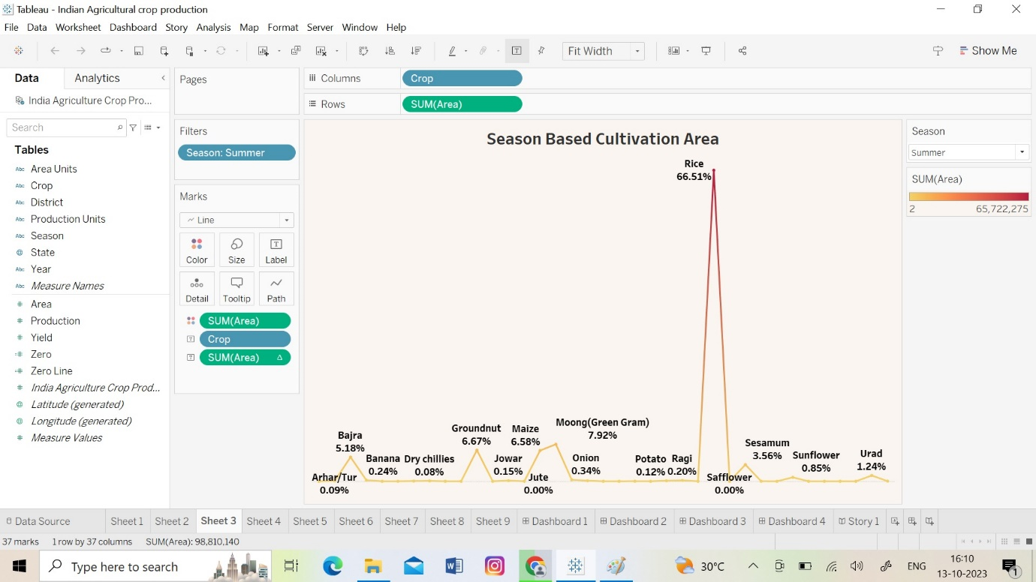

**Sheet 4- Yield by Season**

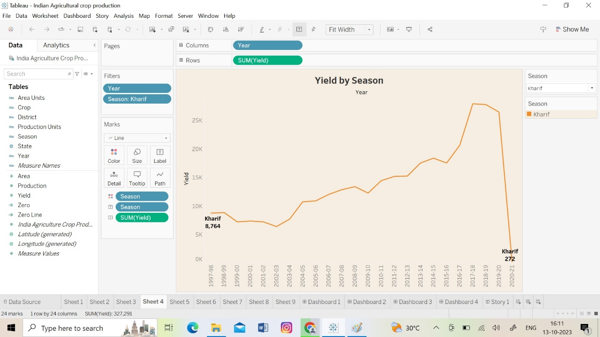

**Sheet 5- Crop Plantation by Area**

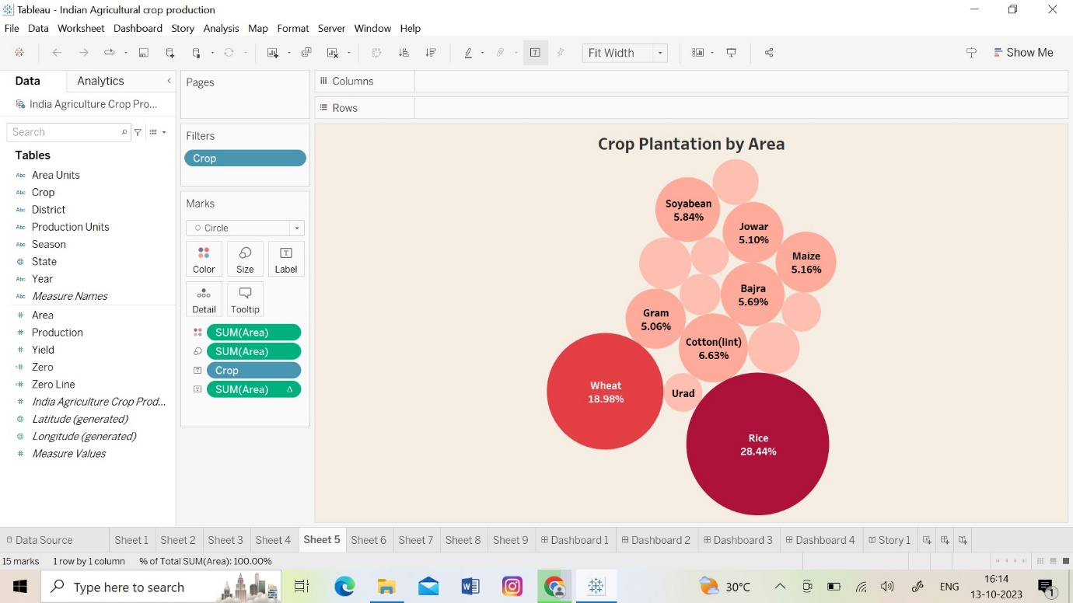

**Sheet 6- Major Crops**

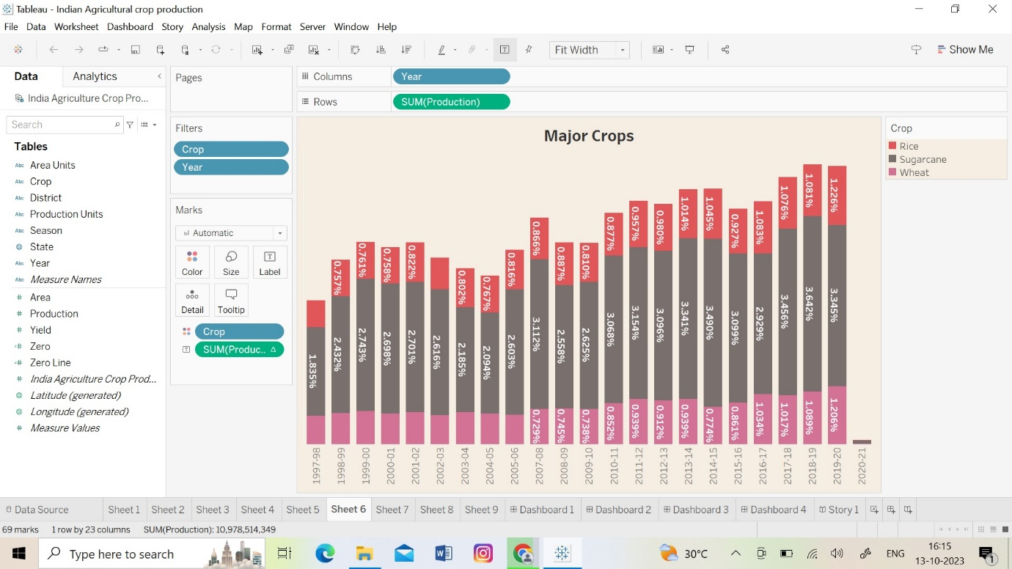

**Sheet 7- Crops (Plantation by count)**

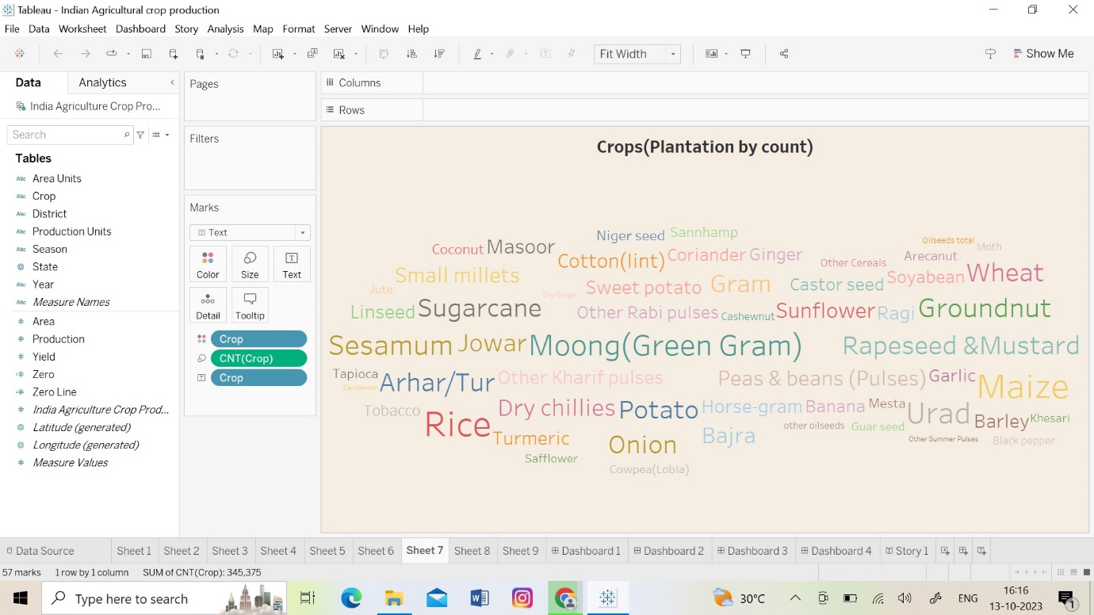

**Sheet 8- Season Wise Production**

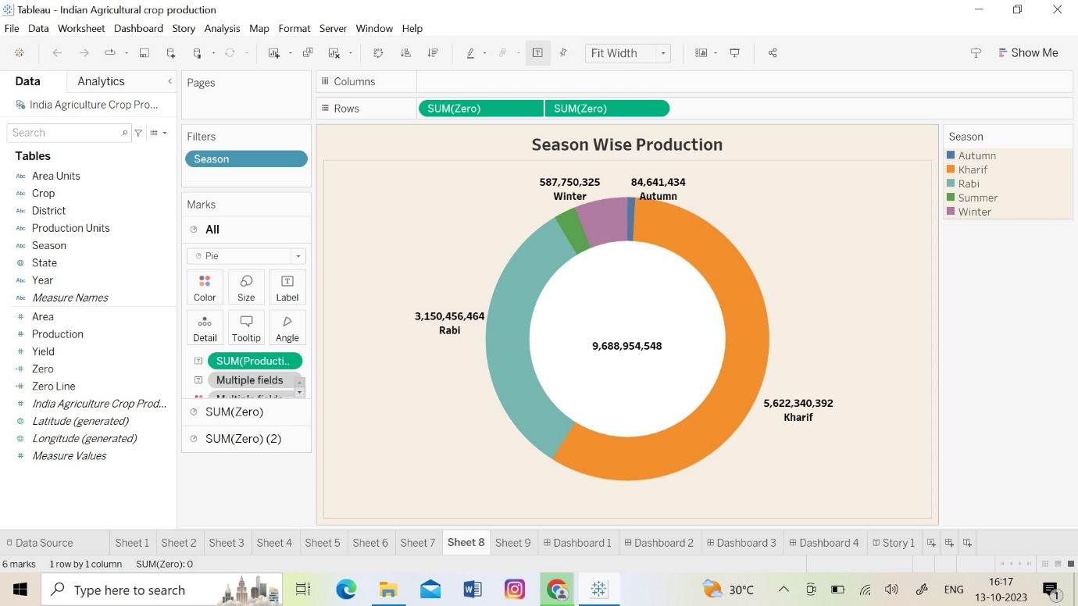

These are the visualizations that were created using the agricultural data.

**4. ADVANTAGES & DISADVANTAGES:**

**\* Advantages:**

i) It enables us to find the crop which is produced more compared to other crops.

ii) It projects the crops which are cultivated and harvested based on various seasons.

**\* Disadvantages:**

i) The natural calamities which affected the crop cultivation caused a major impact in production.

**5. APPLICATIONS:**

This data enables the people to understand the crop cultivation in India and will encourage and promote people to adopt agriculture as their profession and passion.

**6. CONCLUSION:**

Here we have made a deep study on Indian Agriculture Crop Production and have displayed the data visually.

**7. FUTURE SCOPE:**

To promote the increase of cultivation land.